ARKANSAS OPEN CHAMPIONSHIPS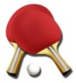

Date: JUNE 17,2023

Sanctioned by: USATT 1-Star Tournament | Venue: DAILEY FITNESS CENTER
Hosted by: LRTTC, AITTA, & ATTA | 300 S Monroe
Sponsored by: AITTA, facebook.com/arkansastabletennis/ | Little Rock, Arkansas, 72205

 | SANCTIONED EVENTS | TYPE | START | 1ST | 2ND | 3RD
1 | OPEN ABCD ROUND ROBIN | RR | 8:30A
 | OPEN SINGLES | RR | 2:00P | $200+T | $100+T
 | A SINGLES | RR | 2:00P | $40+T | T
 | B SINGLES | RR | 2:00P | $20+T | T
 | C SINGLES | RR | 2:00P | $20+T | T
 | D SINGLES | RR | 2:00P | $20+T | T
 | NON SANCTIONED EVENTS
2 | OPEN DOUBLES | RR | NOON | $100+T | $60+T | Per team
3 | U3400 DOUBLES | RR | NOON | T | T
4 | U2600 DOUBLES | RR | NOON | T | T
5 | U2000 DOUBLES | RR | NOON | T | T
Tournament Director Eugene Atha
Tournament Referee: Eugene Atha; Co-Tournament Referee Jamey Hall (Certified Referee)
Tournament Umpire: Jamey Hall (International)
ELIGIBILITY:
Open to all players and must be a member of the USATT (except for non-sanctioned events listed above).

TOURNAMENT RULES:
- OPEN A-B-C-D ROUND ROBIN: Limited to the first 50 entries and open to all players. Each group will have 3-5 players; all players will advance to second round robin. Winners of each group advance to Open Singles; second place to A Singles, etc. Format after the second round robin will be determined by number of entries.
- OPEN/U3400/U2600/U2000 DOUBLES: Players have until 10am to find a partner. Maximum of 6 teams in all divisions; players must have a USATT rating to play in the U3400/U2600/U2000 Doubles events. All events will be round robin groups of three – second round format determined by number of entries & time available.
- EQUIPMENT: Stiga/Donic tables; Stiga and Tibhar nets; Nittaku poly white 3 star premium 40 mm balls; wood flooring.
- All USATT rules apply. Rackets must meet USATT regulations.
- Events with less than 3 entries may be cancelled or combined with the next higher rated event.
- All matches are best 3 out of 5 games - games to 11.
- All players must report to the control desk 20 minutes prior to the start time of their first event.
- No lunch provided so plan accordingly. Forfeits will be called if players have left the tournament site without permission of the Tournament Director or Control Desk.
- No refunds the day of the tournament, except in doubles if a partner cannot be found.
- The rating posted on the USATT website as of the entry deadline will be a participant’s rating.
- A player may not enter 2 or more events that start at the same time.
- Matches must be played for prize money to be awarded. Splitting of prize money is not allowed.
- Facility opens at 7a date of tournament.

Entry Form

Mail entries to: ARKANSAS OPEN c/o Eugene Atha, 1608 Club Lane East, Sherwood, AR 72120.
(Make checks out to Eugene Atha)
Phone entries: Call Eugene Atha (501) 835-5291 or leave a message.
Email Entries: email to: eatha@swbell.net.

NAME: ____________________________________________ PHONE: _____ - _____-_______
STREET: __________________________ CITY: _____________ STATE: ZIP: _______-______
EMAIL ADDRESS: ______________________________________ BIRTHDATE: _____/_____/_____
USATT Membership Expires: ____/____ RATING: ______________
DOUBLES PARTNER: _______________________________________
ENTRY DEADLINE: JUNE 14,2023
See fees below - check events entered

✓ |  | Event | PAY BY  6/12/23 | PAY BY  6/14/23 | PAY ON  6/17/23
 | 1. | OPEN ROUND ROBIN | $40.00 | $45.00 | $50.00
 | 2. | OPEN DOUBLES PER PLAYER | $20.00 | $25.00 | $30.00
 | 3. | U3400 DOUBLES PER PLAYER | $15.00 | $20.00 | $25.00
 | 4. | U2600 DOUBLES PER PLAYER | $15.00 | $20.00 | $25.00
 | 5. | U2000 DOUBLES PER PLAYER | $15.00 | $20.00 | $25.00
 |  | FACILITY FEE | $8.00 | $8.00 | $8.00
 |  | MEMBERSHIP/PLAYING PERMIT
 |  | DONATION TO NATIONAL TEAM
 |  | LATE ENTRY FEE |  |  | $5.00
 |  | SUBTOTAL FEES
 |  | TOTAL ENTRY + FEES
Payment must be received by 6/14/23 to receive discount.

Non-USATT members may enter sanctioned events by purchasing a USATT membership or playing permit.
Membership fees are: 1 Year Basic $25 Pro $75 Lifetime $1300
Playing permit $50 Adult; $20 Juniors

Please enter me in the above events. I agree to comply with all USATT Regulations.

WAIVER: I accept full responsibility for my participation and relieve the sponsors, the AITTA, the USATT, the LRTTC and the venue/facility of any liability resulting from injury to myself or damage to my property.

SIGNATURE__________________________________________________________ (Guardian if minor)

DATE ___________________________

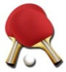Directions

From I-630W: Take Exit 4 and go right on Fair Park Boulevard. At the intersection of Fair Park Boulevard and Zoo Drive, turn right onto Zoo Drive.

From Asher Ave./Hwy 5: Turn North onto Fair Park Boulevard. At the intersection of Fair Park Boulevard and Zoo Drive, turn right onto Zoo Drive.

Parking: As you drive down Zoo Drive, the Dailey Fitness Center will be on the left just past the Zoo entrance.

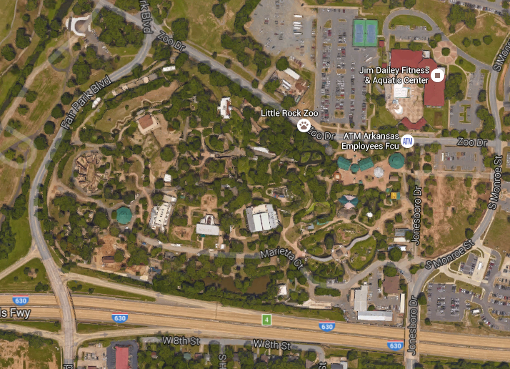

PRACTICE SITES

LITTLE ROCK TABLE TENNIS CLUB
300 S MONROE LITTLE ROCK AR 72205
SATURDAY 10A-1P

ARKANSAS TABLE TENNIS ACADEMY
15716 McARTHUR DRIVE UNIT C
WEDNESDAY 6:30P-9P
SUNDAY 9:30A-3P

ARKANSAS INDEPENDENT TABLE TENNIS ASSOCIATION
508 SHERWOOD AVENUE SHERWOOD AR 72120
TUESDAY & THURSDAY 5-7P

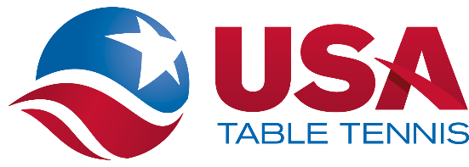

USATT SAFE SPORT PROTOCOL
ENTRY BLANK TEMPLATE FOR USATT SANCTIONED TOURNAMENTS

I understand USATT’s Safe Sport Policy including the organization’s Coaching Policy, which requires that all persons who are engaged in coaching activities at USATT Affiliated Member Clubs and/or USATT Sanctioned Tournaments, except parents or legal guardians coaching their own children, must be fully Safe Sport Compliant, which includes completing SafeSport Training offered by the US Center for SafeSport every year and undergoing a criminal background screen every two years.

I understand that, pursuant to USATT’s Minor Athlete Abuse Prevention Policy, all participants at USATT Sanctioned Tournaments who are over the age of 18 and have regular contact with or authority over minor athletes must complete annual SafeSport Training offered by the US Center for SafeSport.

More information on USATT’s Safe Sport Policy is available at: https://www.teamusa.org/usa-table- tennis/athlete-safety/safe-sport.

End. 23 02-22a
Local Amenities

Hotels

Days Inn on Fair Park Blvd.

Clarion on University Ave.

Restaurants

Fair Park & Markham Subway, Chi’s Chinese Cuisine, Jimmy’s Serious Sandwiches

Fair Park Blvd.: U.S. Pizza, Riviera Maya

12th Street: Pepe's Mexican Restaurant, Church's Chicken, Rally's, Subway
Grady's Pizza and Subs

Asher Ave.: China Plus Buffet, Taco Bell, Captain D's, KFC

University Ave.: Zack's Place, Catfish City and BBQ Grill, Senior Tequila, Papa John's, Pizza Hut, Popeye's, Go Go China, Subway, Little Caesar's, Denny's, Wendy's, Long John Silver's, McDonald's

Groceries

Walgreens at the corner of University Ave. and Asher Ave.

Kroger on Asher Ave.

Banks

Regions on Asher Ave.
Bank of America and Arvest on University Ave.

